**QUESTION 1**

To come up with improved consumer selective advertisement strategies, AT&T wants to start maintaining a call log of which of its customers called which of its other customers. Each customer may call any number of other customers. The call log records the caller IDs of the consumers who dialed a call and caller IDs of consumers who received a call. The call log also records the call’s time, date and duration.

**1.Business rules:**

* Each customer has to make at least one call.
* Each receiver either receives one call or no call.
* In my model receiver cannot receive more than one call.

**MS VISIO:**

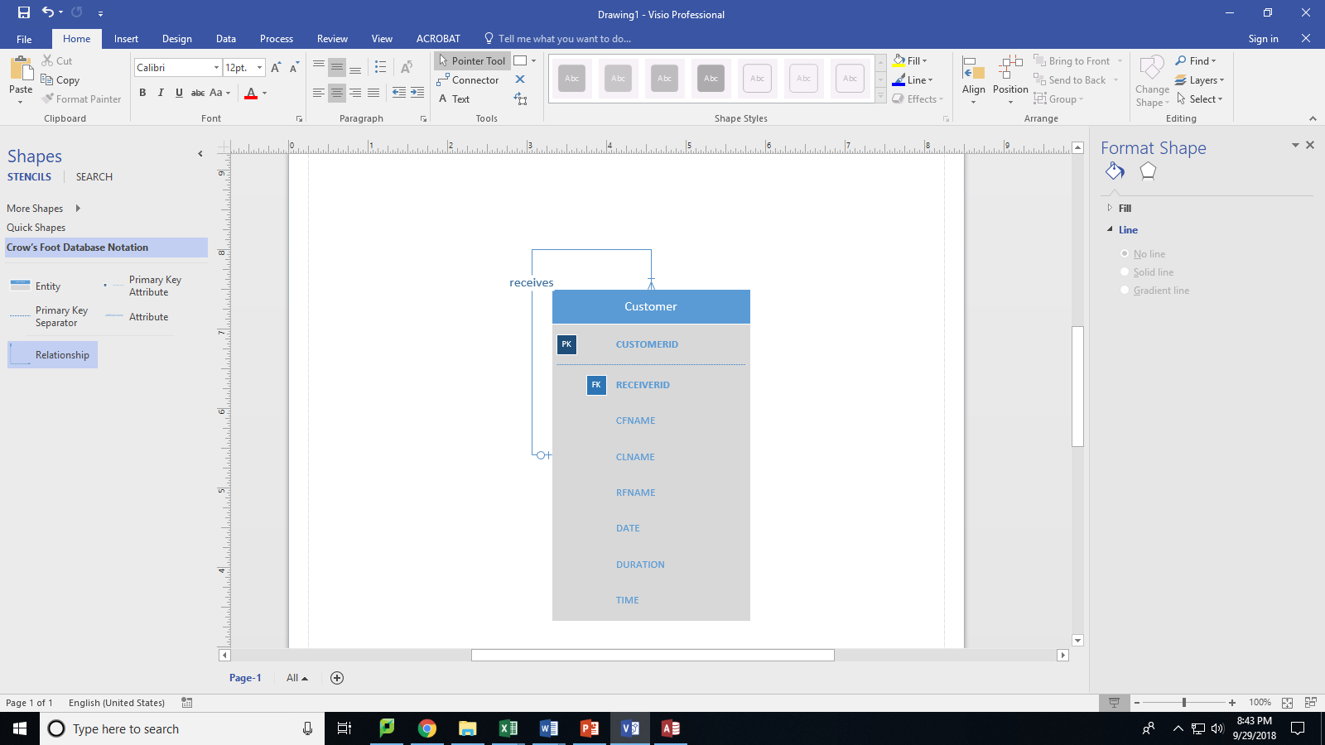

**MS Access:**



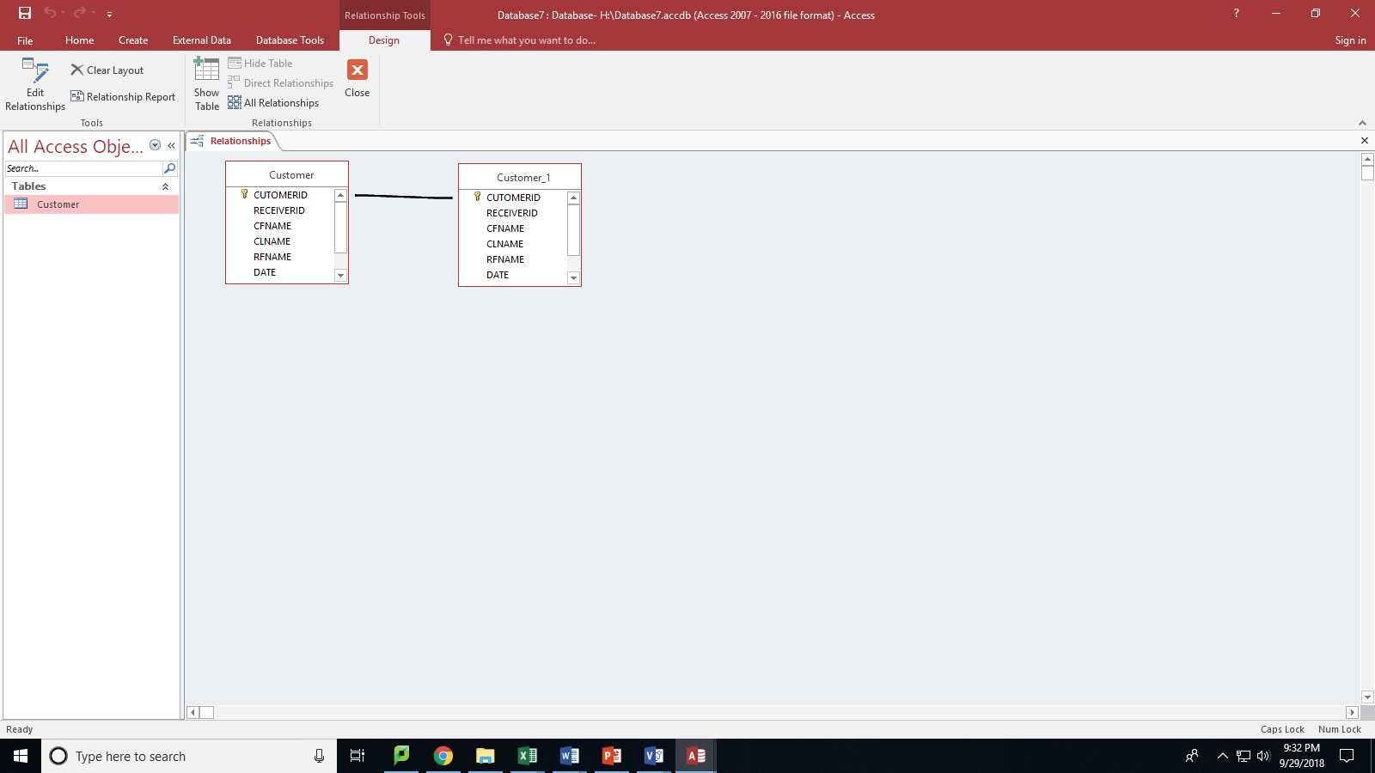

**QUESTION 2**

Propose one business rule that has a many-to-many binary relationship. You can choose either an identifying relationship (composite key) or non-identifying (surrogate key) relationship to implement it. But please explain how you decide which relationship to use.

BUSINESS RULES:

1. Each student has to register for at least one class.
2. Each course must have at least one student.

**MS VISIO:**



MS ACCESS:

STUDENT:



REGISTERS:



COURSE:



I have used RID as surrogate primary key as non-identifying relationship because of simple implementation. Also, change in coursed or studentid won’t affect my registers table.

RELATIONSHIP:

